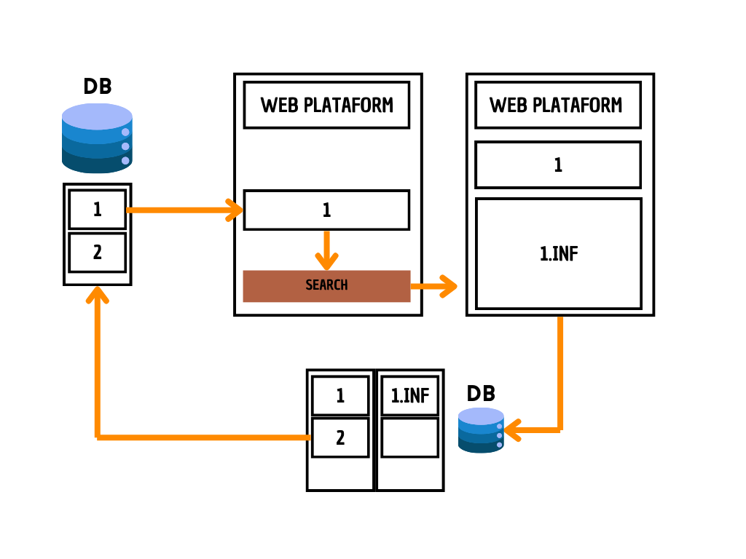

Project 1 Web Scraping

The Web Scraping Project extracts information from a web environment using input parameters, stores it in a dataframe, and allows for future analysis. It automates login, navigation, and data extraction, repeating the process in a loop. The code is easily editable to extract information from other platform sections or perform repetitive tasks.

**\*\*Here are the questions I was interested in answering\*\***

1) How can we extract information from a web platform using input parameters?

2) How is the extracted information structured and stored for future analysis?

3) How should the code be made to adapt its functionality to other processes?

**\*\*I took the following steps to create my analysis\*\***

1) Configure the automation of web login and navigation.

2) Define the timeouts required to access the data extraction areas.

3) Repeat the process in a loop for each required value of the input data.

4) Save the extracted data in a dataframe for further analysis

5) Adjust the code to extract information from different platform sections or perform repetitive tasks.

**\*\*Here are my takeaways\*\***

1) The Web Scraping project allows the extraction and management of information from the web environment in an automated way.

2) The information is stored in a dataframe, facilitating future analysis.

3) The code is easily editable for other data extraction needs or repetitive tasks.